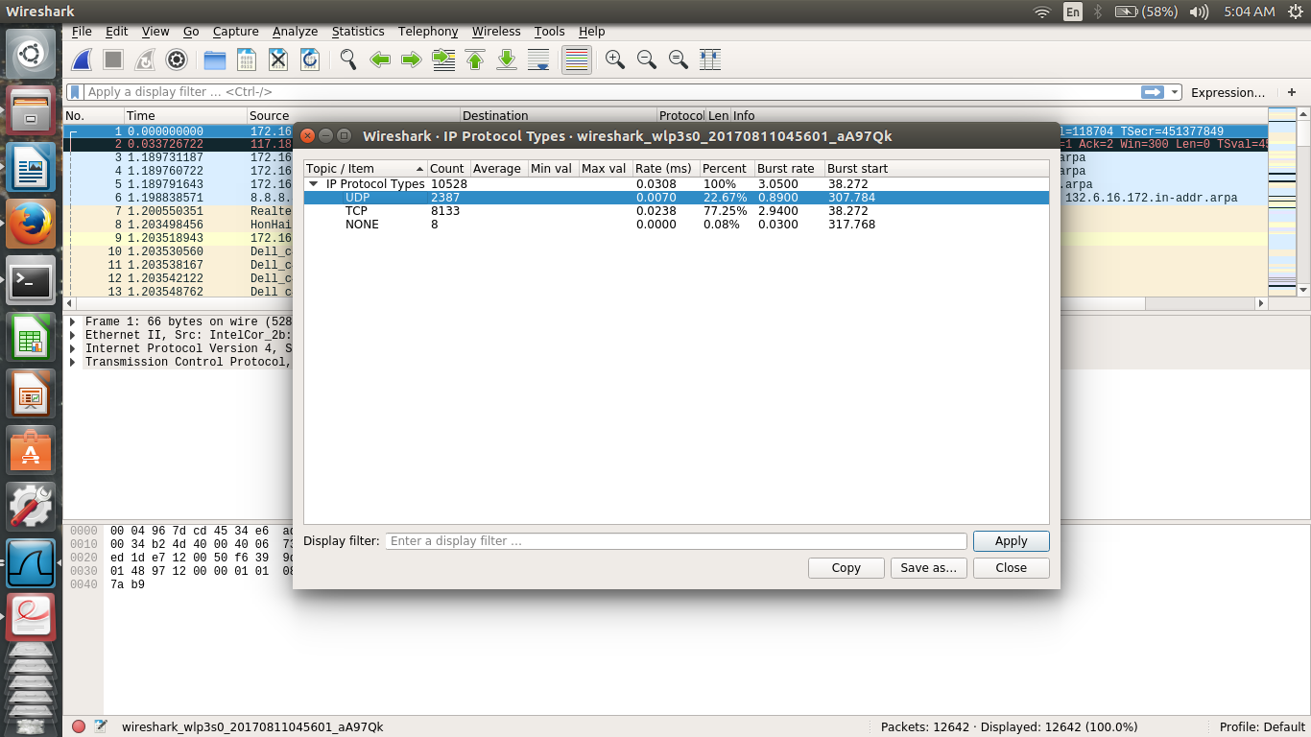
EXERCISE 2

*Statistics -> ipv4 statistics -> IP protocal types

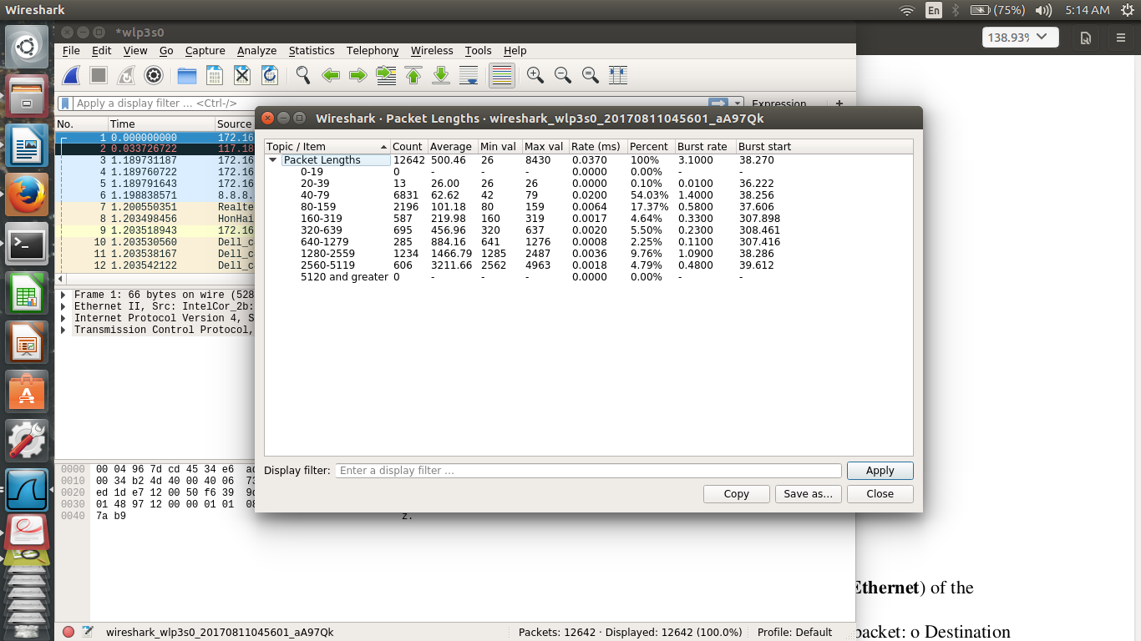
statictics -> packet lengths

to display dropped packets

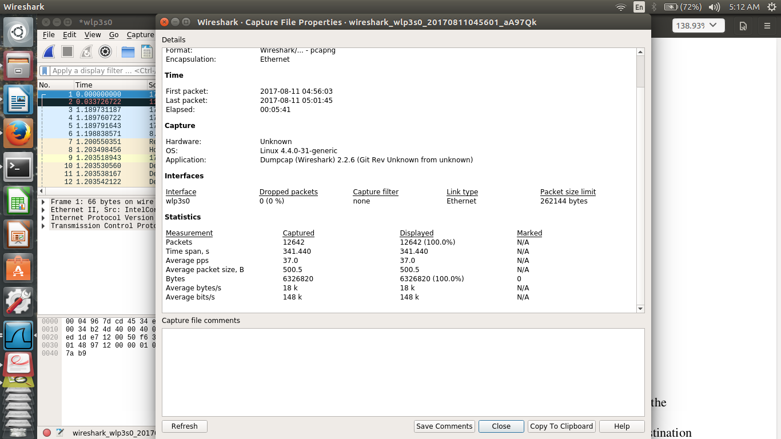
* statistics -> capture file properties
or
below the packet bytes total no of packets – dropped packets

